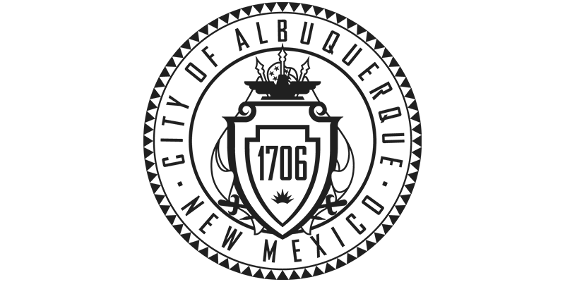City of Albuquerque Property Fact Sheet

Property ID: 102305714313231120
Legal Description: T10N R4E SEC 23 CONTG 0.25 ACRES
Address: Mel Smith Dr. NE, Albuquerque, New Mexico 87123
Acreage: .35
Zoning: R1-C
